**ANSWERS 3.7**

**1.**

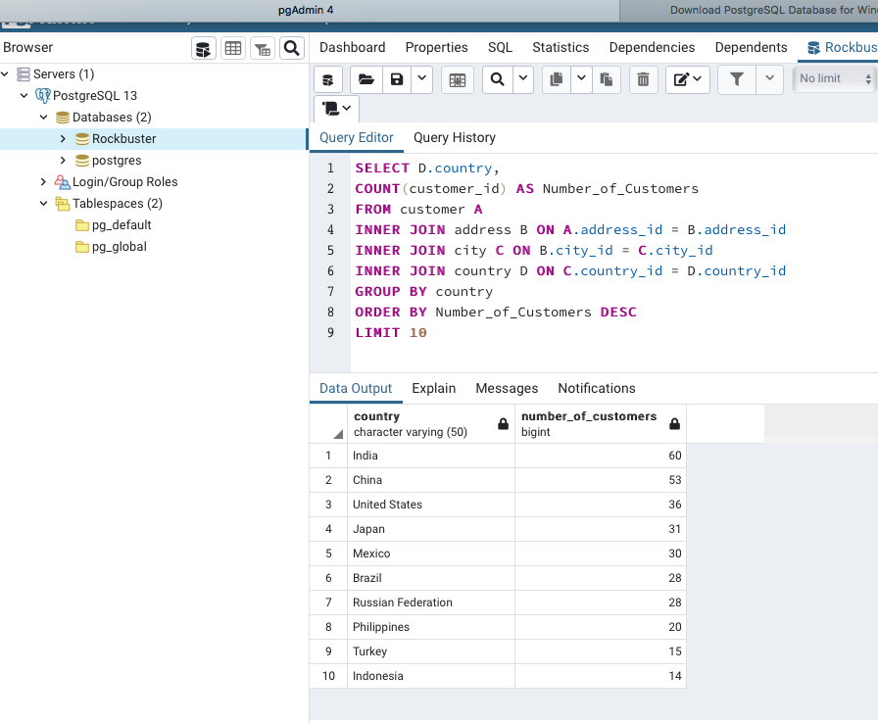

To be able to write this query I first looked on the ERD for Rockbuster data base. This way I found the connection between the list of countries (*country* column and table) and number of customers (*customer_id* column in *customer* table). As they are not directly connected, I had to use multiple joins. Then I used AS to name the new table and GROUP BY to look at customers by country, ORDER BY and DESC to arrange the table from highest to lowest and finally LIMIT the number to countries to create the top ten.

**2.**

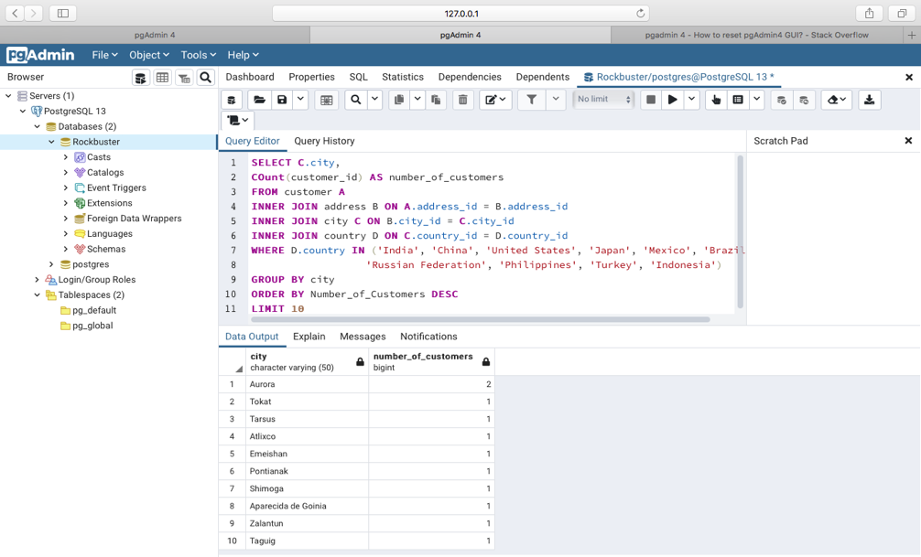

To be able to write the query I used the query in Step 1 and made few changes to be able to find the 10 top cities within the top ten countries. I first added city on the SELECT command to be able to see that column and finally I added the WHERE…IN and added the top ten countries manually so the results were limited to only cities from any of those countries.

**3.**

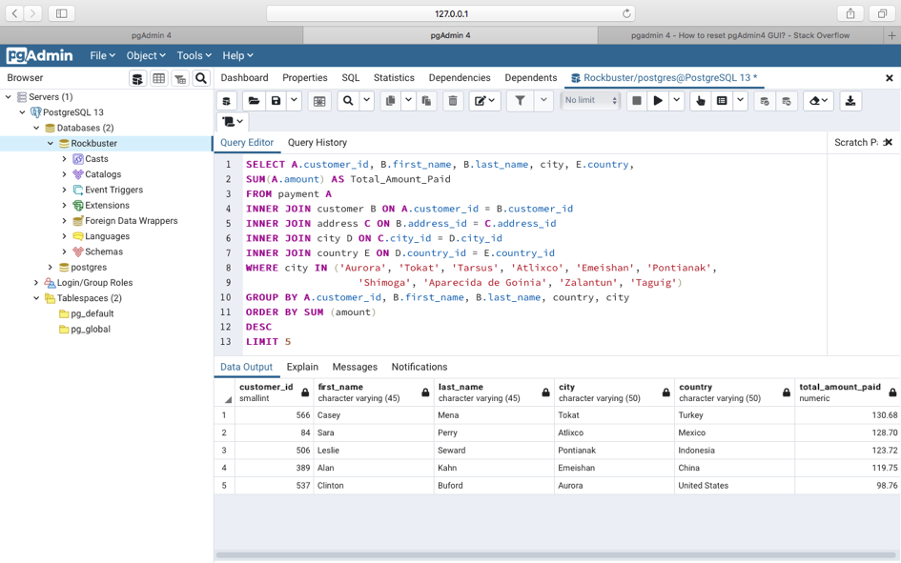

For this query after looking at the ERD of this database I realized I had to link columns from five different tables from *Payment (A)* to *Country (E)* so I also used multiple joins. I wrote all column names required by the task after the SELECT command and then I added the SUM command to calculate the total amount paid by those five customers.

After linking all columns from different tables I used the WHERE…IN to manually write the name of the ten cities from the previous step to find those five customers within those cities only. Later I used the GROUP BY to show the tables requested and finally I used ORDER BY and LIMIT to arrange the values from highest to lowest and choosing only five customers as requested by the exercise.